Apple Cards
A LESSON ON THE IMPORTANCE OF SHARING
Inspired by the books: The Starry Giraffe & An Apple Pie for Dinner
Grades: Pre K - 2nd

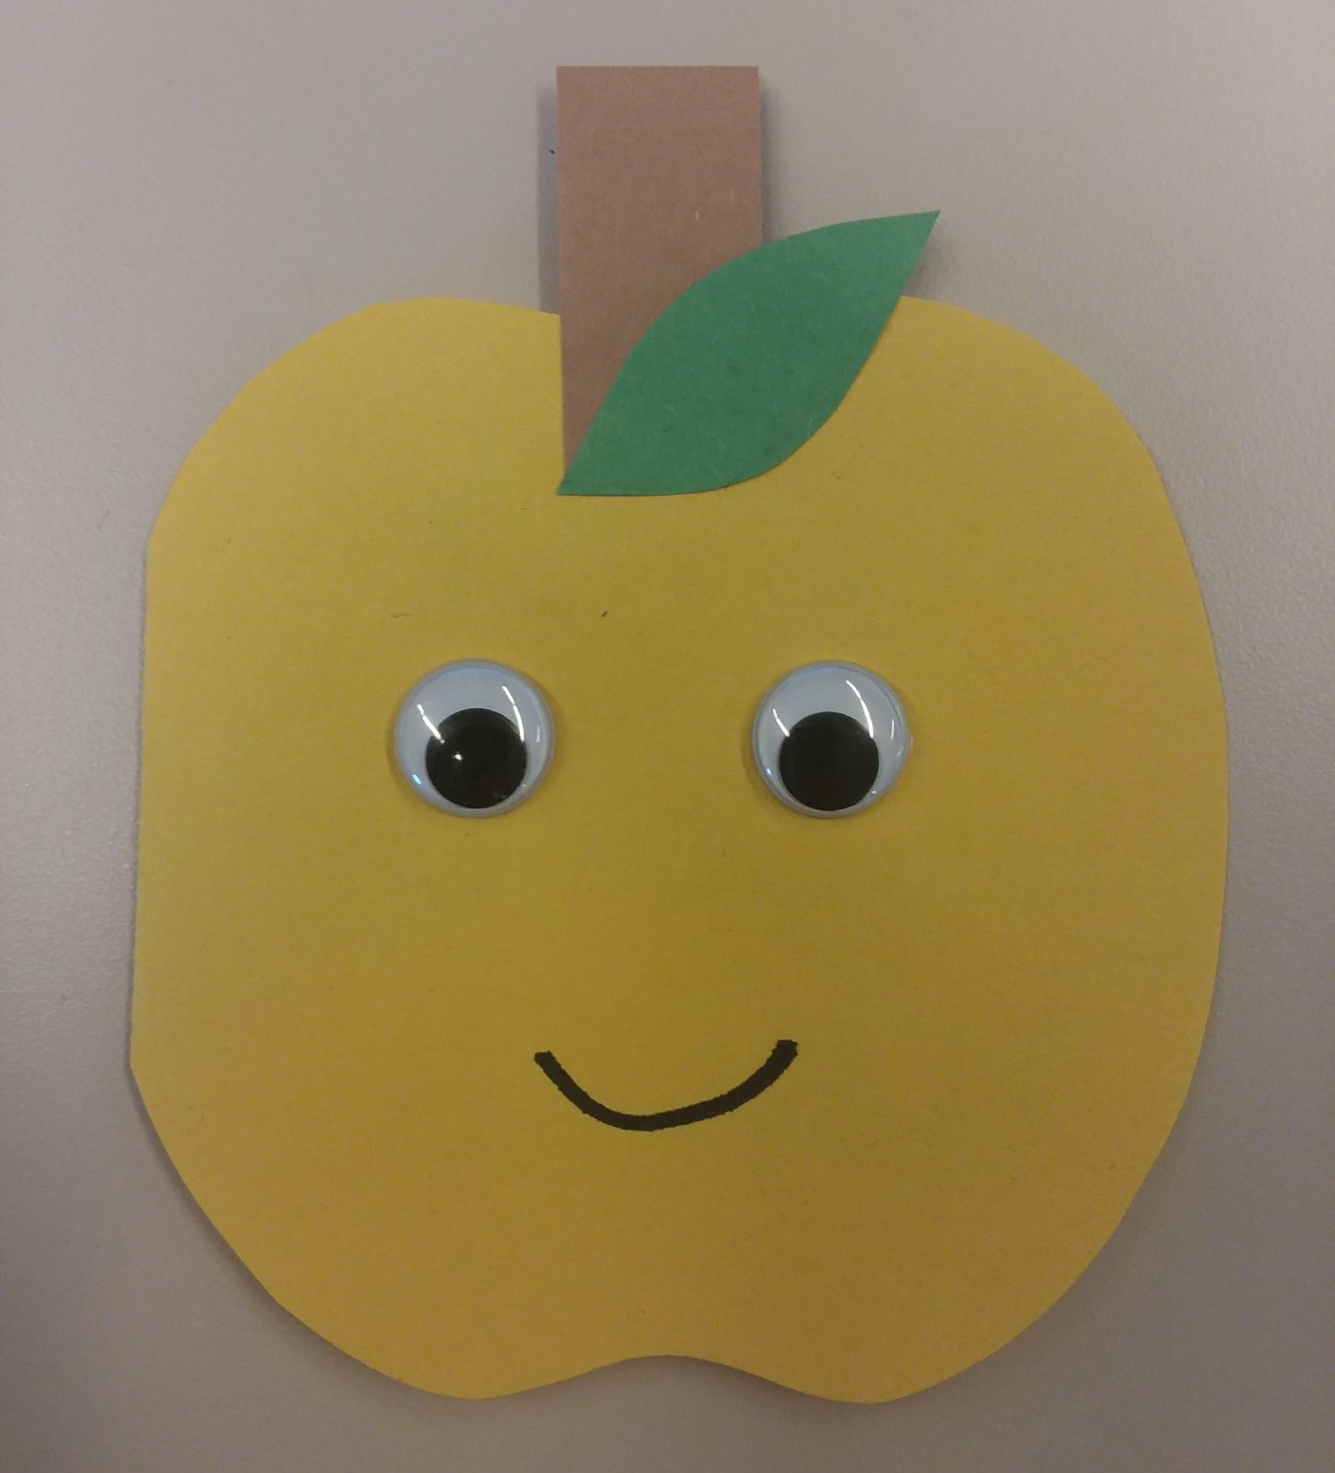
Finished front of apple card.

OBJECTIVES/OUTCOMES
- Students will understand the importance of sharing.
- Students will learn about the parts of an apple.
- Students will make an apple card to take home and give to someone they care about.

DESCRIPTION OF ACTIVITY/CONCEPT
This lesson focuses on teaching students the importance of sharing with each other. Students will listen to how the characters in the stories share apples with people they care about. Then students will be given the opportunity to share an apple with someone they care about by making an apple card with an encouraging message inside. While reading and making the cards, emphasize what the different parts of an apple are and how apples grow to further expand the lesson.

MATERIALS
Construction paper (red, yellow, brown, and Green), glue sticks, googly eyes, and markers.

VOCABULARY
Stem – the main trunk of a plant
Core – the tough central part of an apple, containing the seeds
Seed – a flowering plant's unit of reproduction, capable of developing into another such plant

PROCEDURE
Pre-class Prep
- Cut brown rectangles and green leaves out of construction paper.
- Cut out apple cards from red and yellow construction paper using the template below.
(Adjust Pre-Class Prep, allowing Students to do more cutting based on ability level.)
Class Procedure
3. Students glue the stem, then the leaf, to the top front of their card.
4. Students glue googly eyes to the front center of their card.
5. Students then draw on a smiley mouth with marker.
6. When the front of the card is complete, encourage students to think about who they would like to give their apple card too. Then have the students write a positive message on the inside.
Ex. “You’re Apple-Solutely Wonderful!”
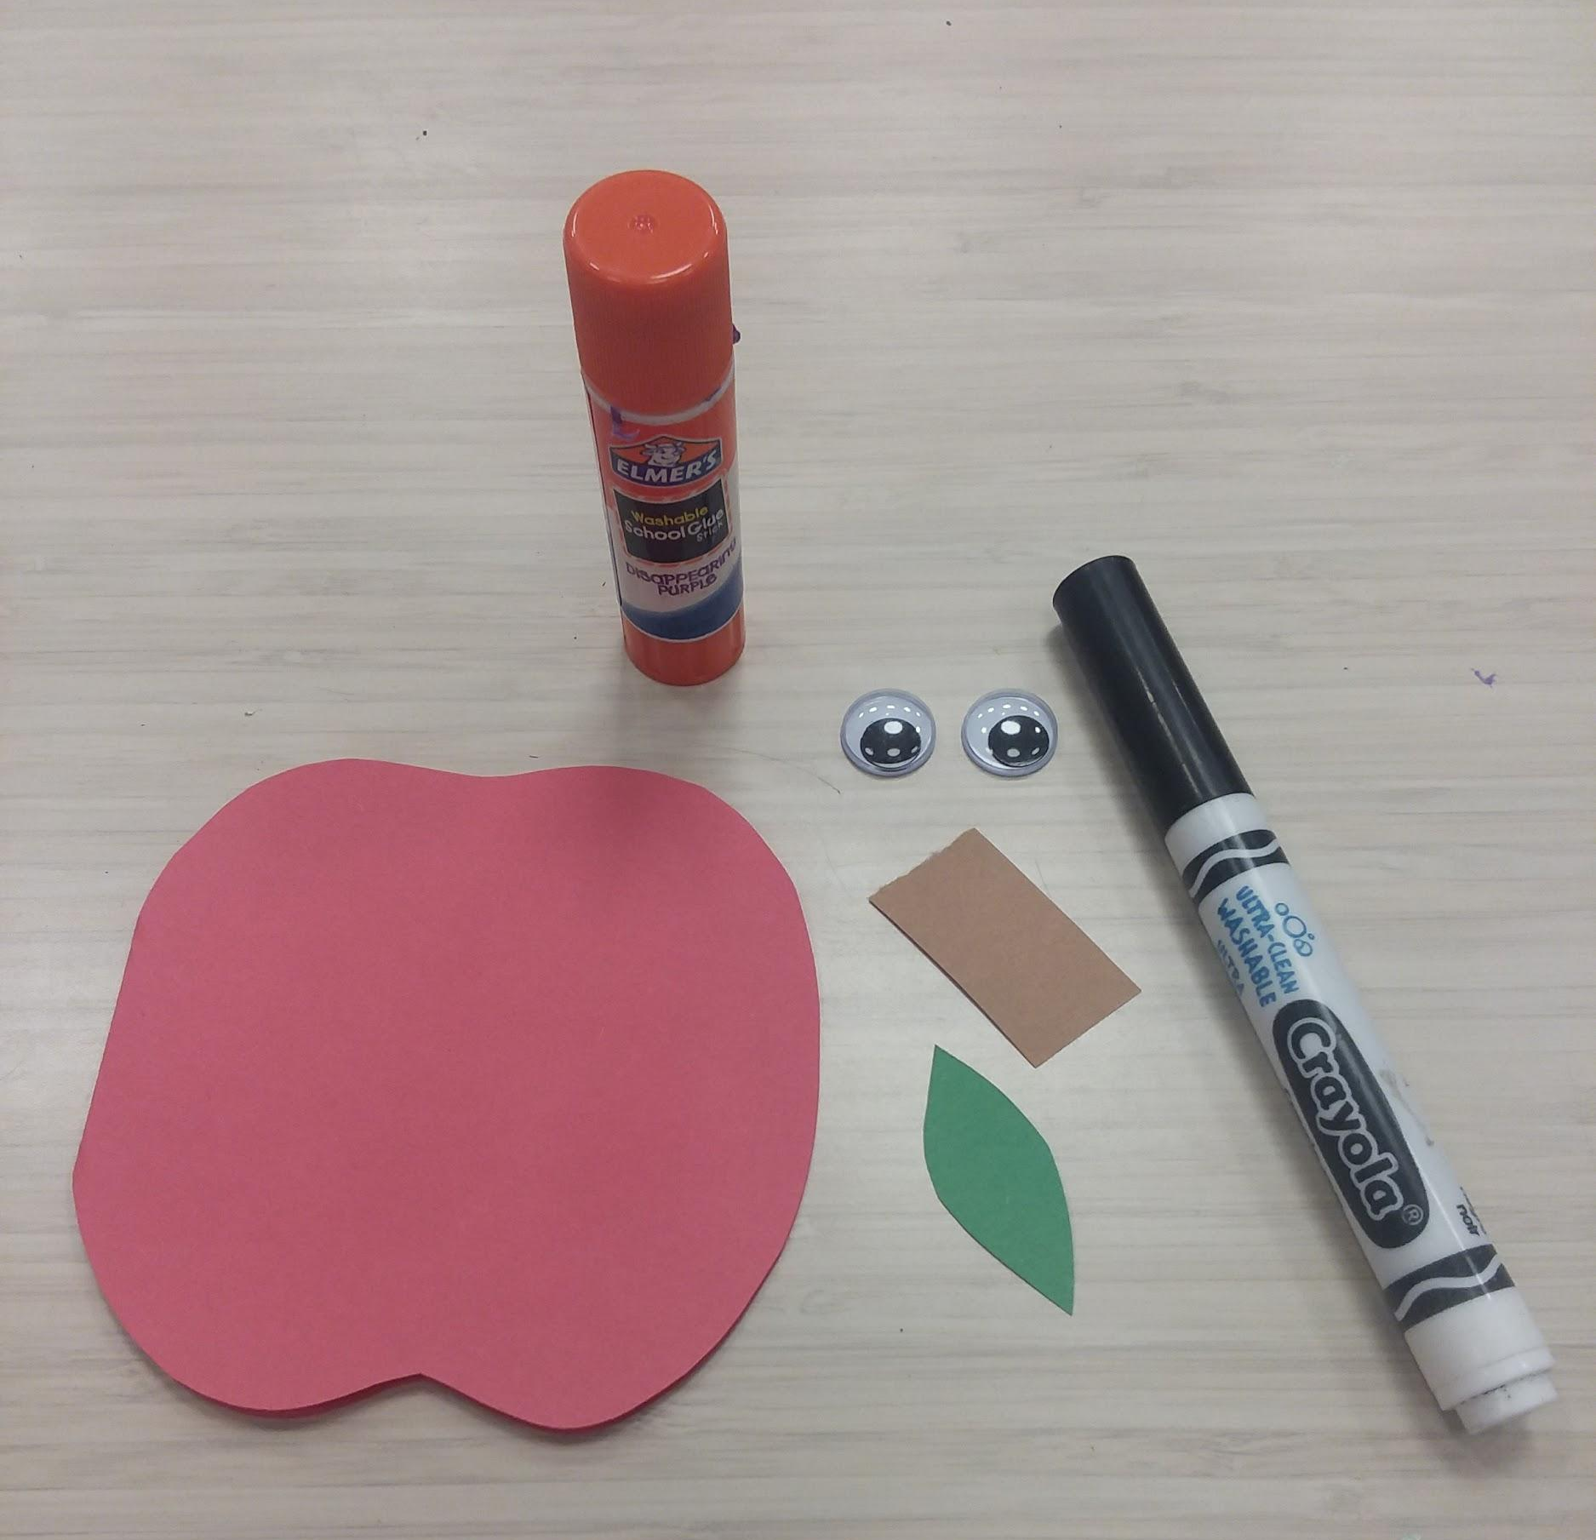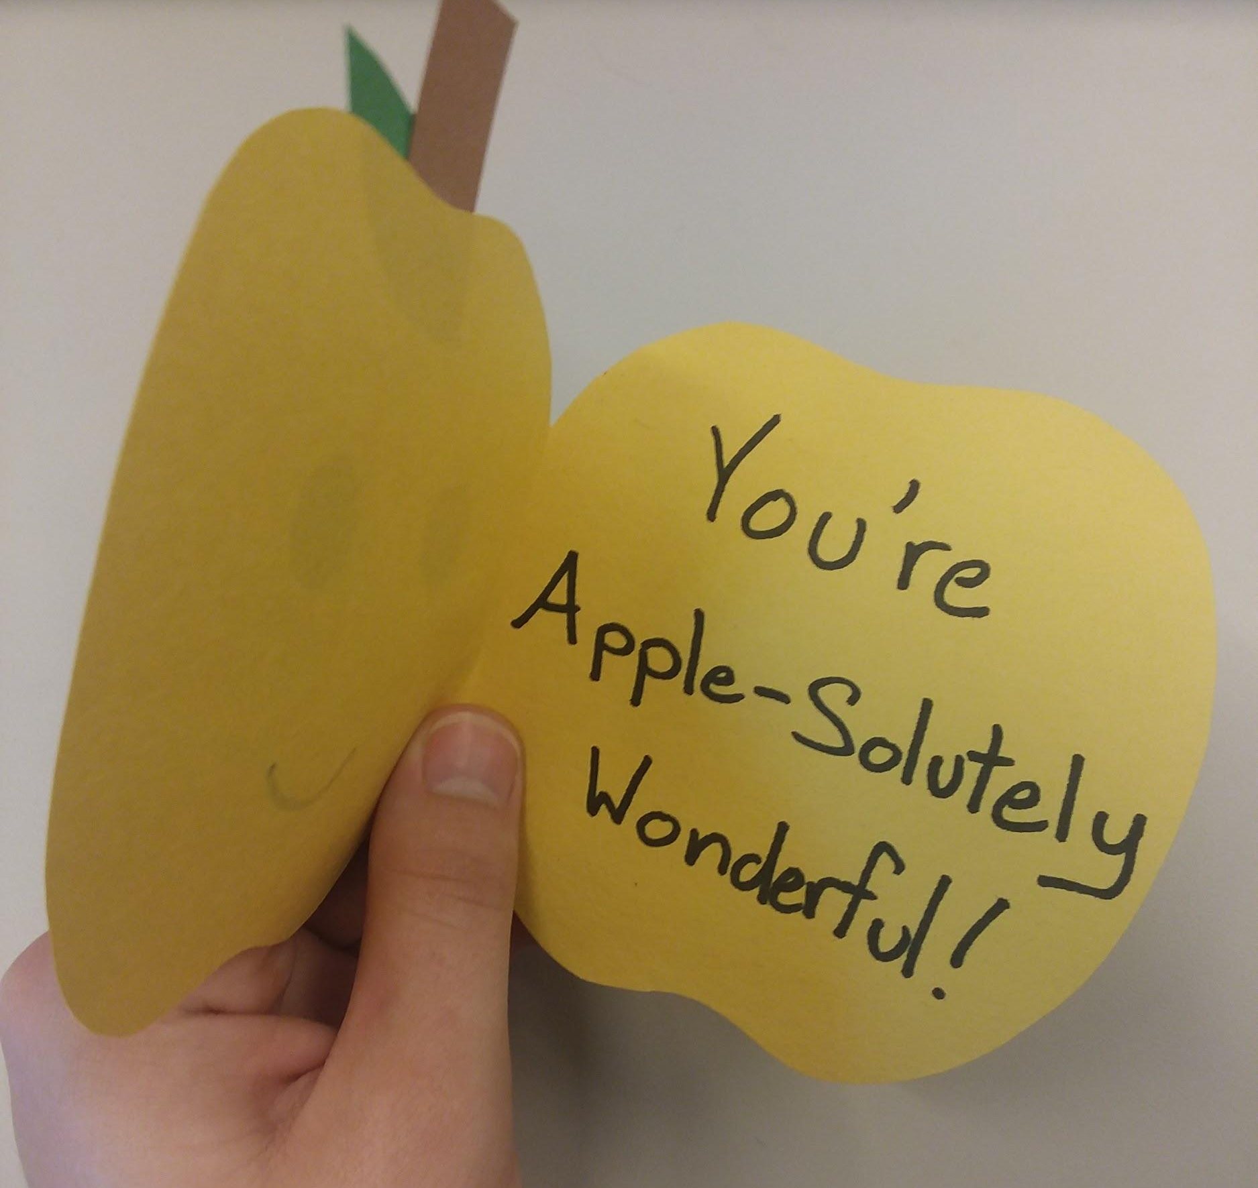

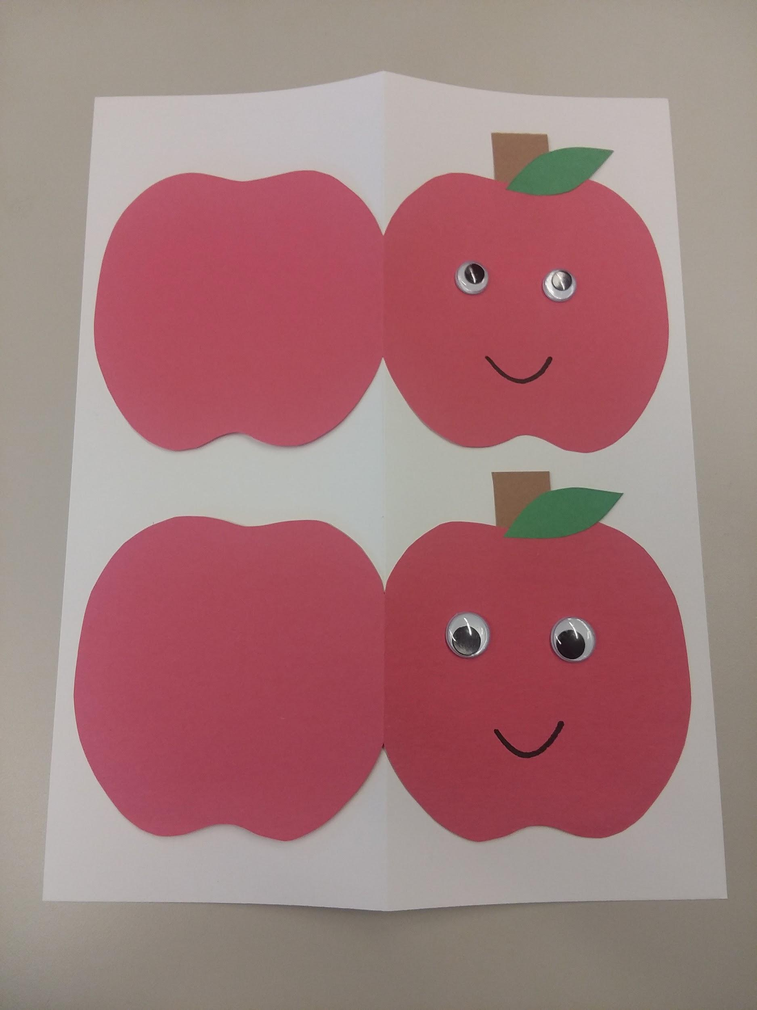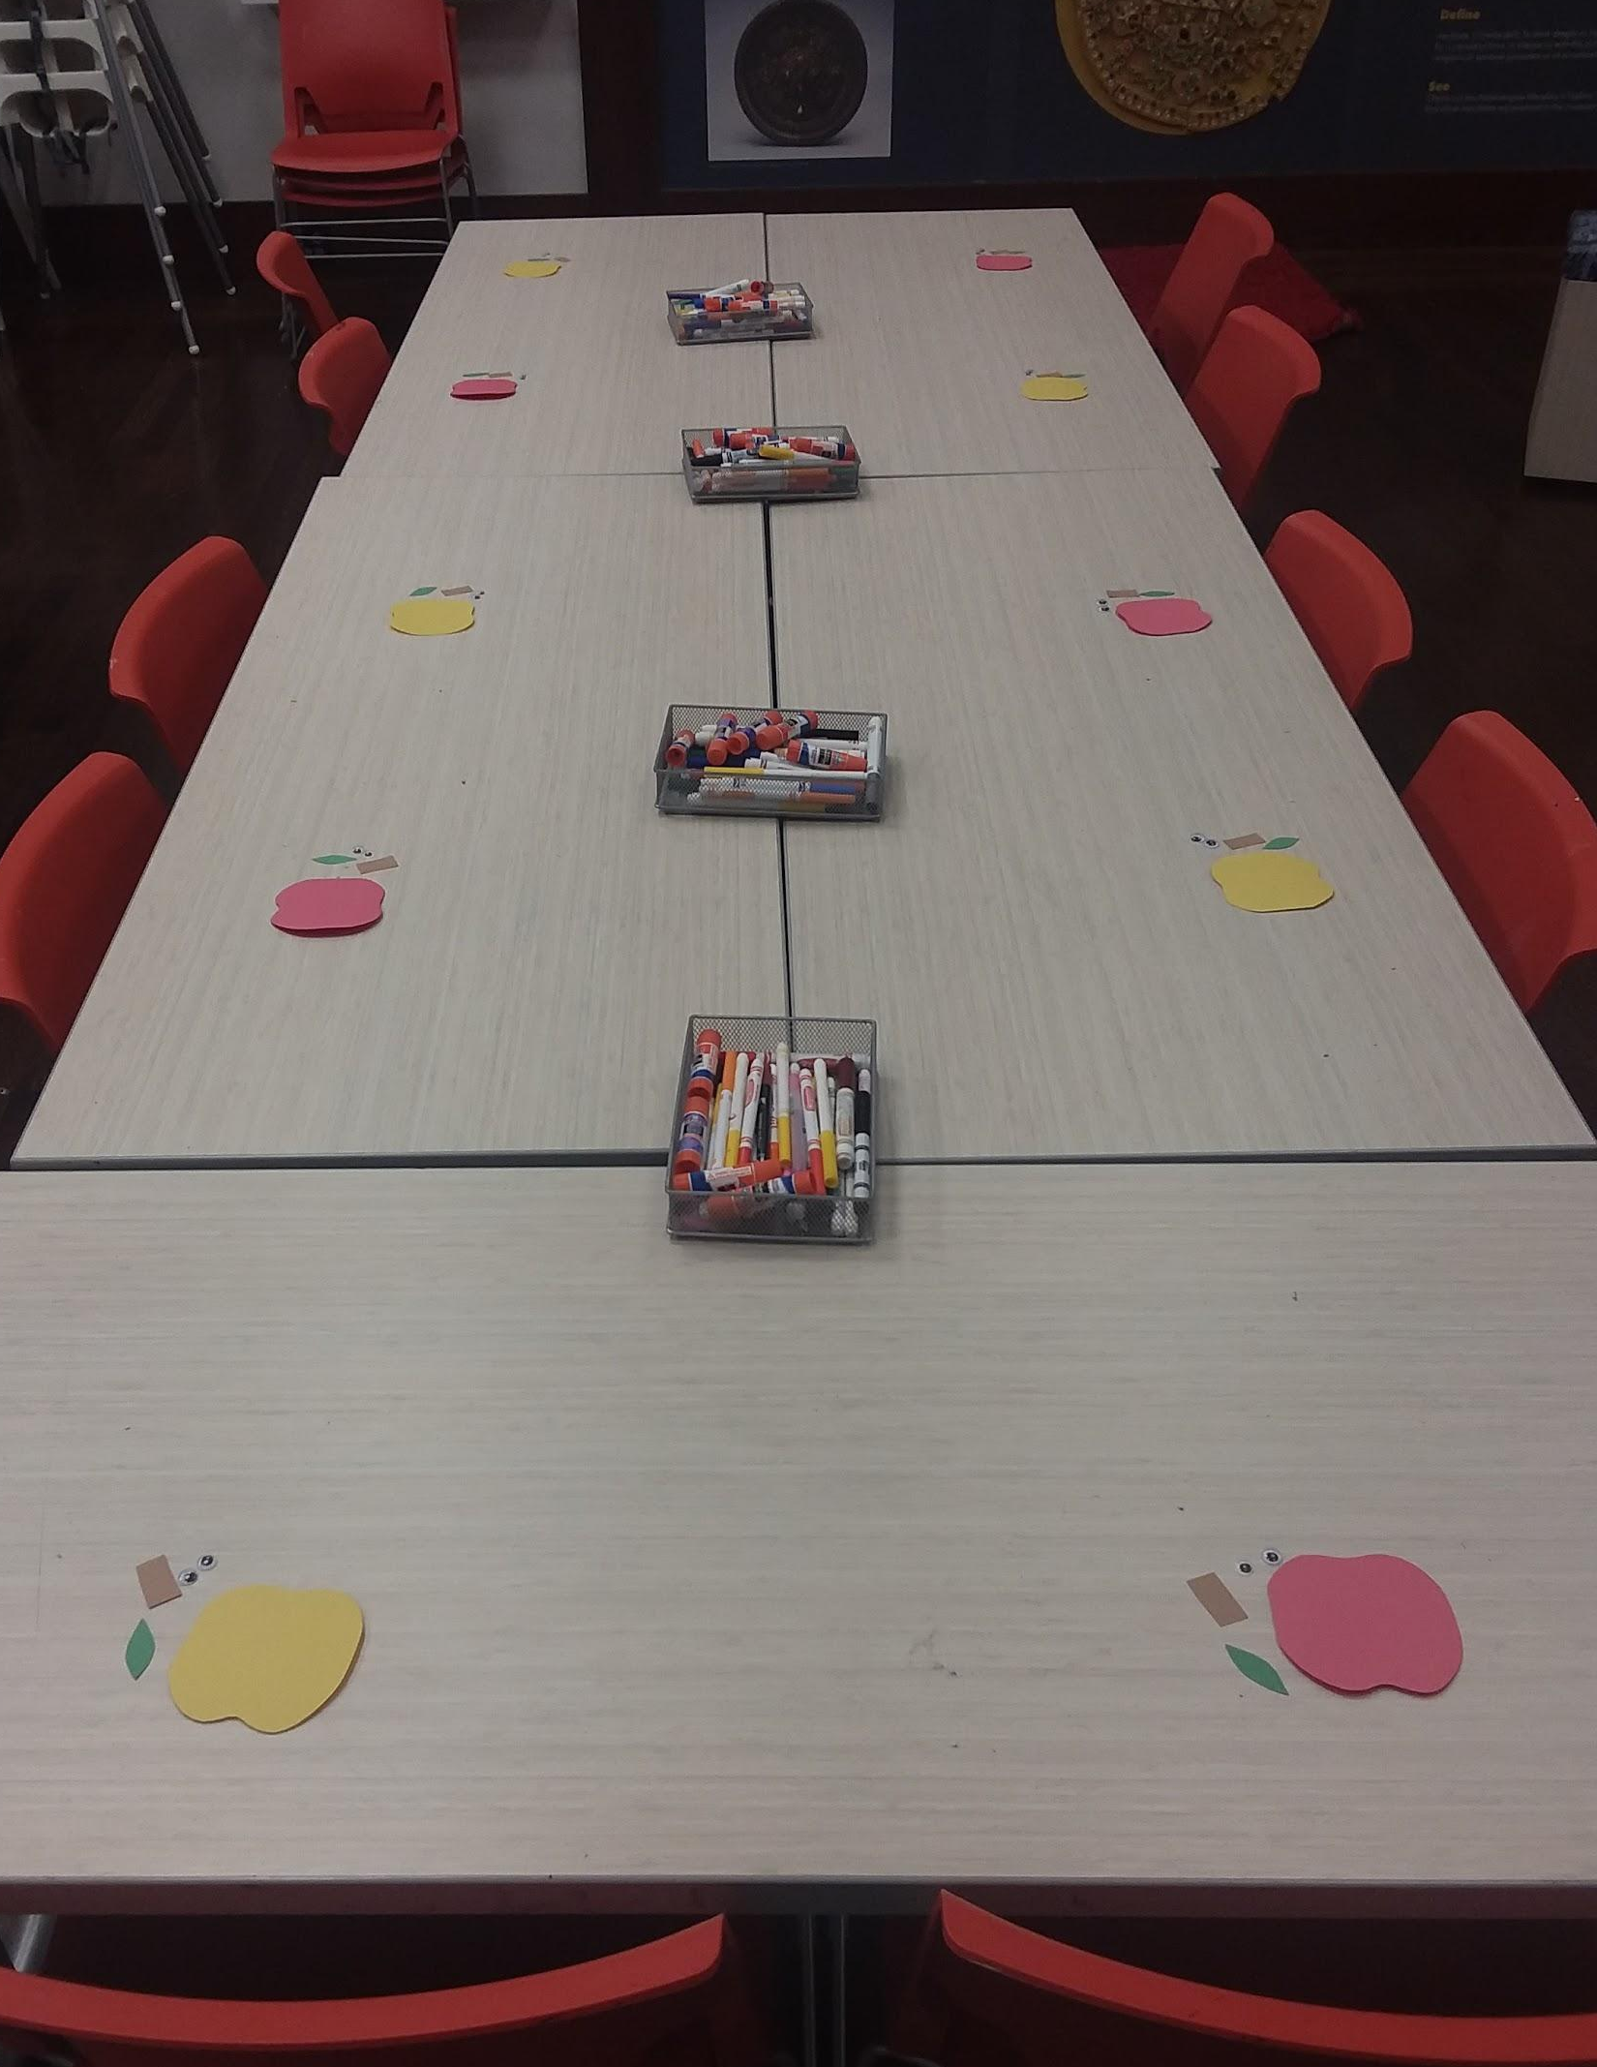

RELATED RESOURCES
Use these books to guide the lesson and add more meaning to the students’ artmaking.
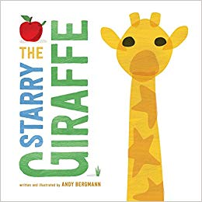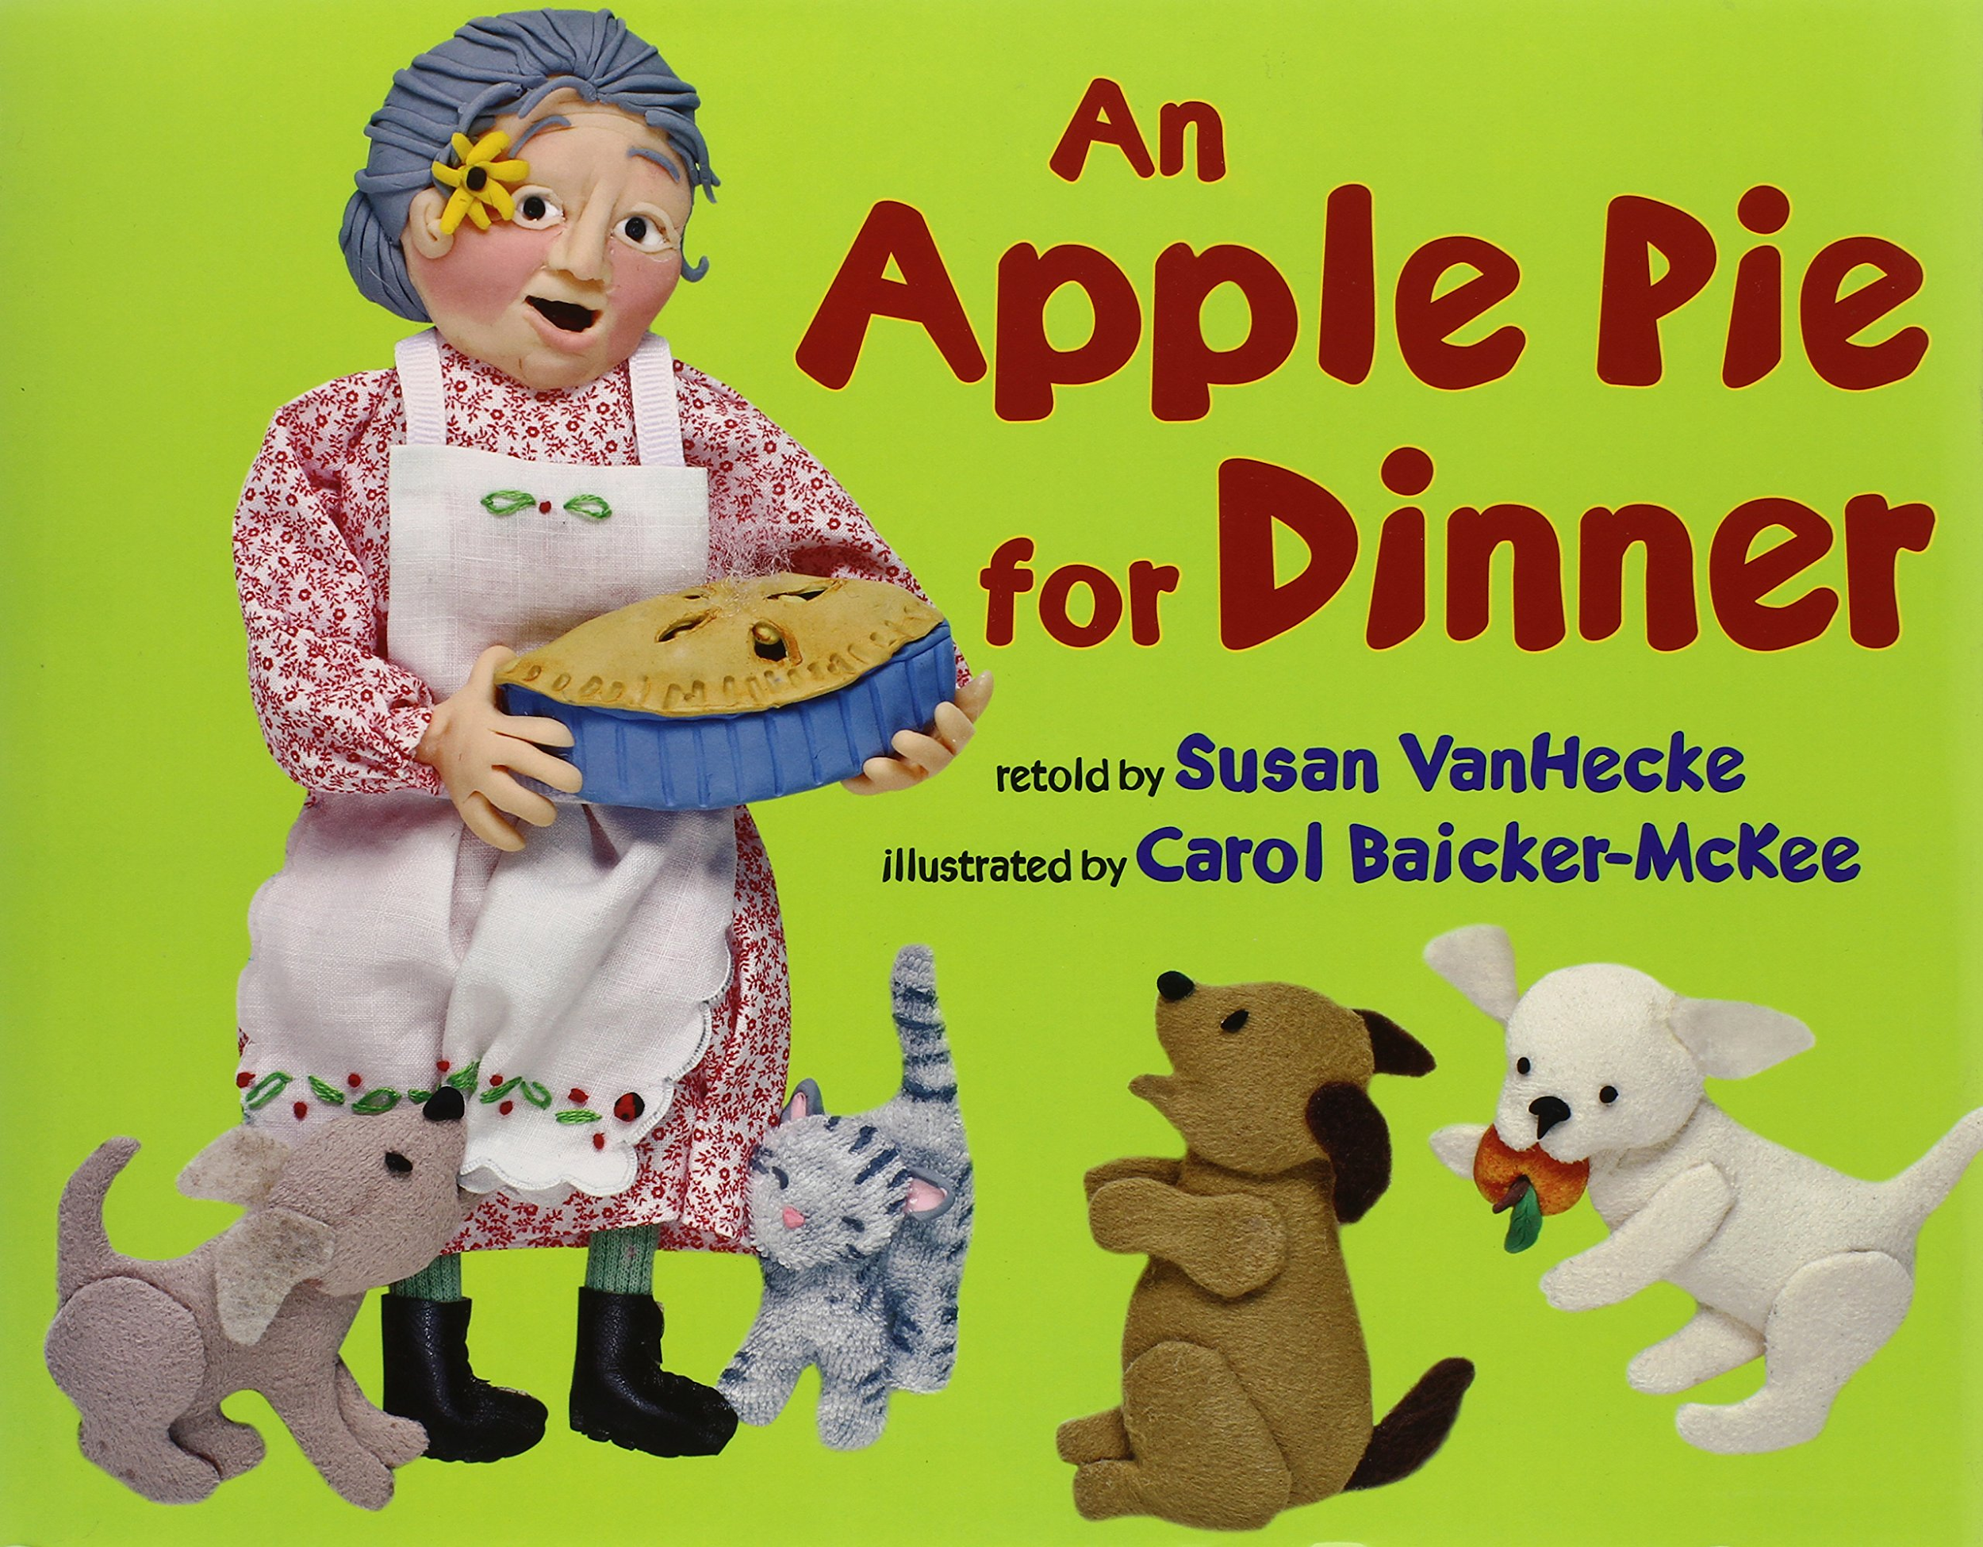
The Starry Giraffe An Apple Pie for Dinner
Andy Bergmann Susan VanHecke

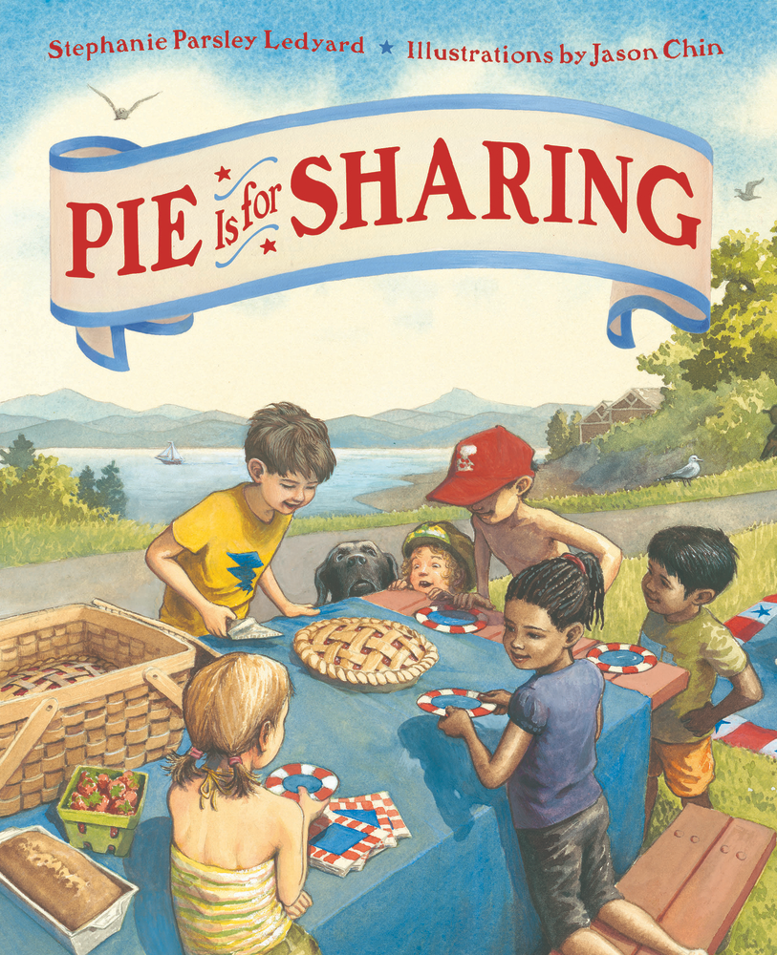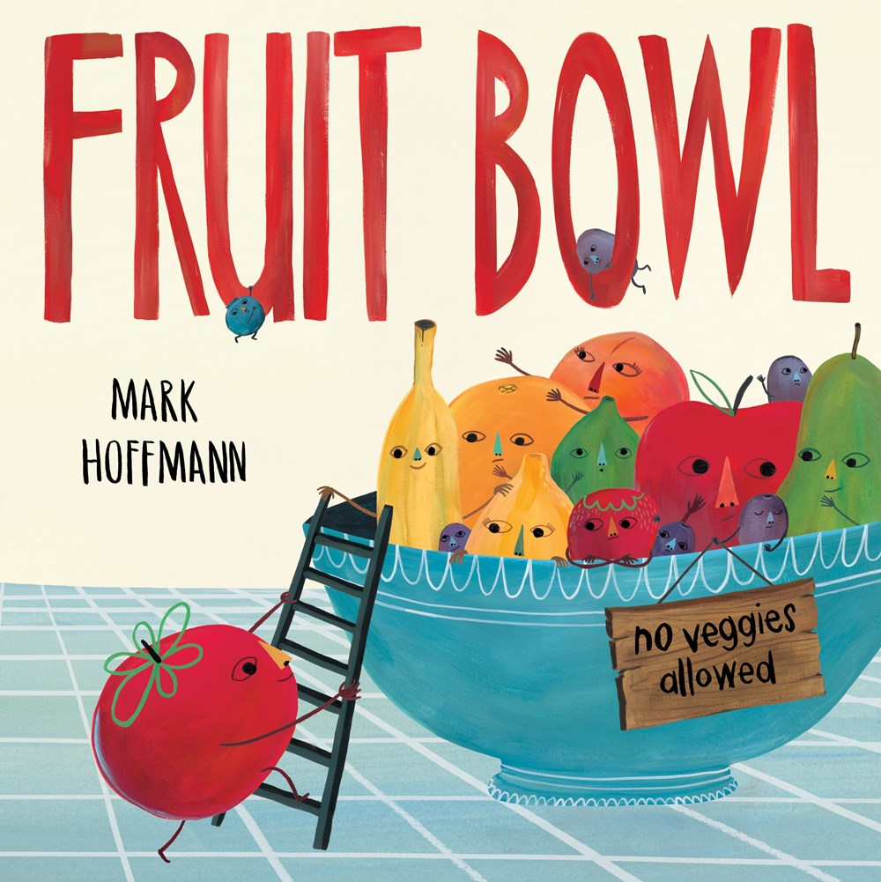
Pie is for Sharing Fruit Bowl
Stephanie Parsley Ledyard Mark Hoffmann

ADDITIONAL ACTIVITIES
Incorporate these additional learning activities to enhance the lesson.
The American Sign Language Sign for Apple:
