ALPHABET BAGS
A SENSORY ACTIVITY ON LANGUAGE
Inspired by the books: Chicka Chicka Boom Boom & Handmade Alphabet
Grades: Pre K - 2nd

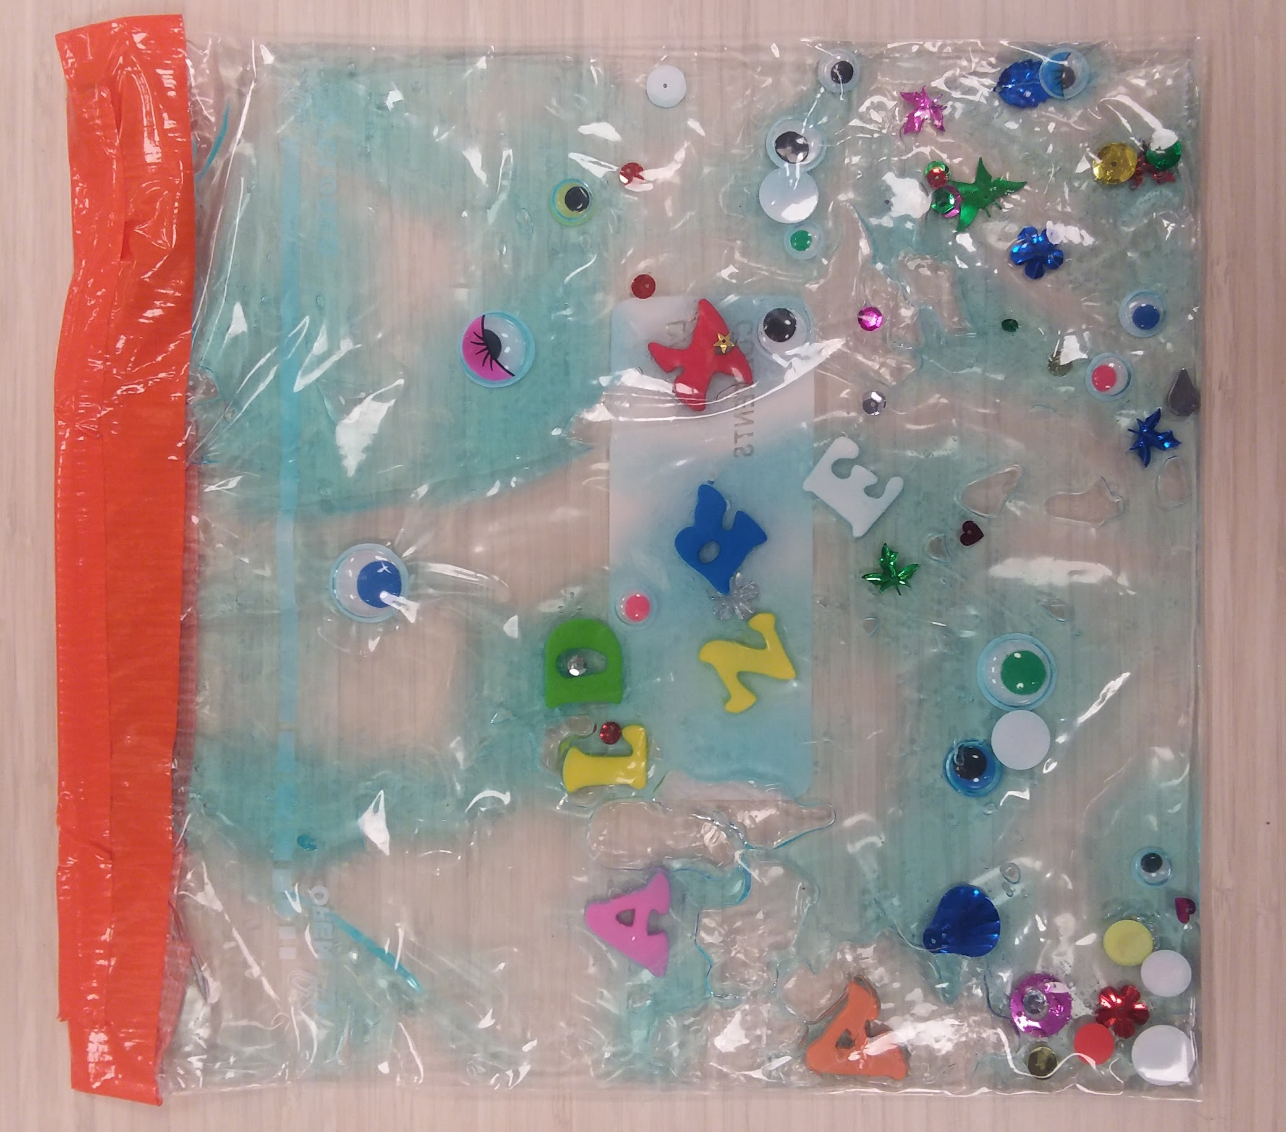
Alphabet / eye spy themed sensory bag

OBJECTIVES/OUTCOMES
- Students will learn the letters of the English alphabet.
- Students will learn how to sign the alphabet in American Sign Language.
- Students will learn what letters are used to spell their name.

DESCRIPTION OF ACTIVITY/CONCEPT
Students will create an alphabet sensory bag with the letters of their name. Students will also learn how to sign the alphabet in American Sign Language. The sensory bag will provide students with a learning tool that will engage their sense of touch, smell, and sight in learning language.

MATERIALS
Hair gel, gallon freezer bags, duct tape, foam letters, googly eyes, sequence.

VOCABULARY
Sign Language – a system of communication using visual gestures and signs, as used by deaf people
Alphabet – a set of letters or symbols in a fixed order, used to represent the basic sounds of a language; in particular, the set of letters from A to Z.

PROCEDURE
- Students will look through the foam letters and spell out their name.
- Then have the students add their letters, googly eyes, and sequence together in their gallon bag.
- Help students add hair gel into their bag.
- Seal bags well.
- Duct tape the top of the bag to ensure that no gel leaks out.
- Encourage students to move the letters around in their bags to spell out their name.

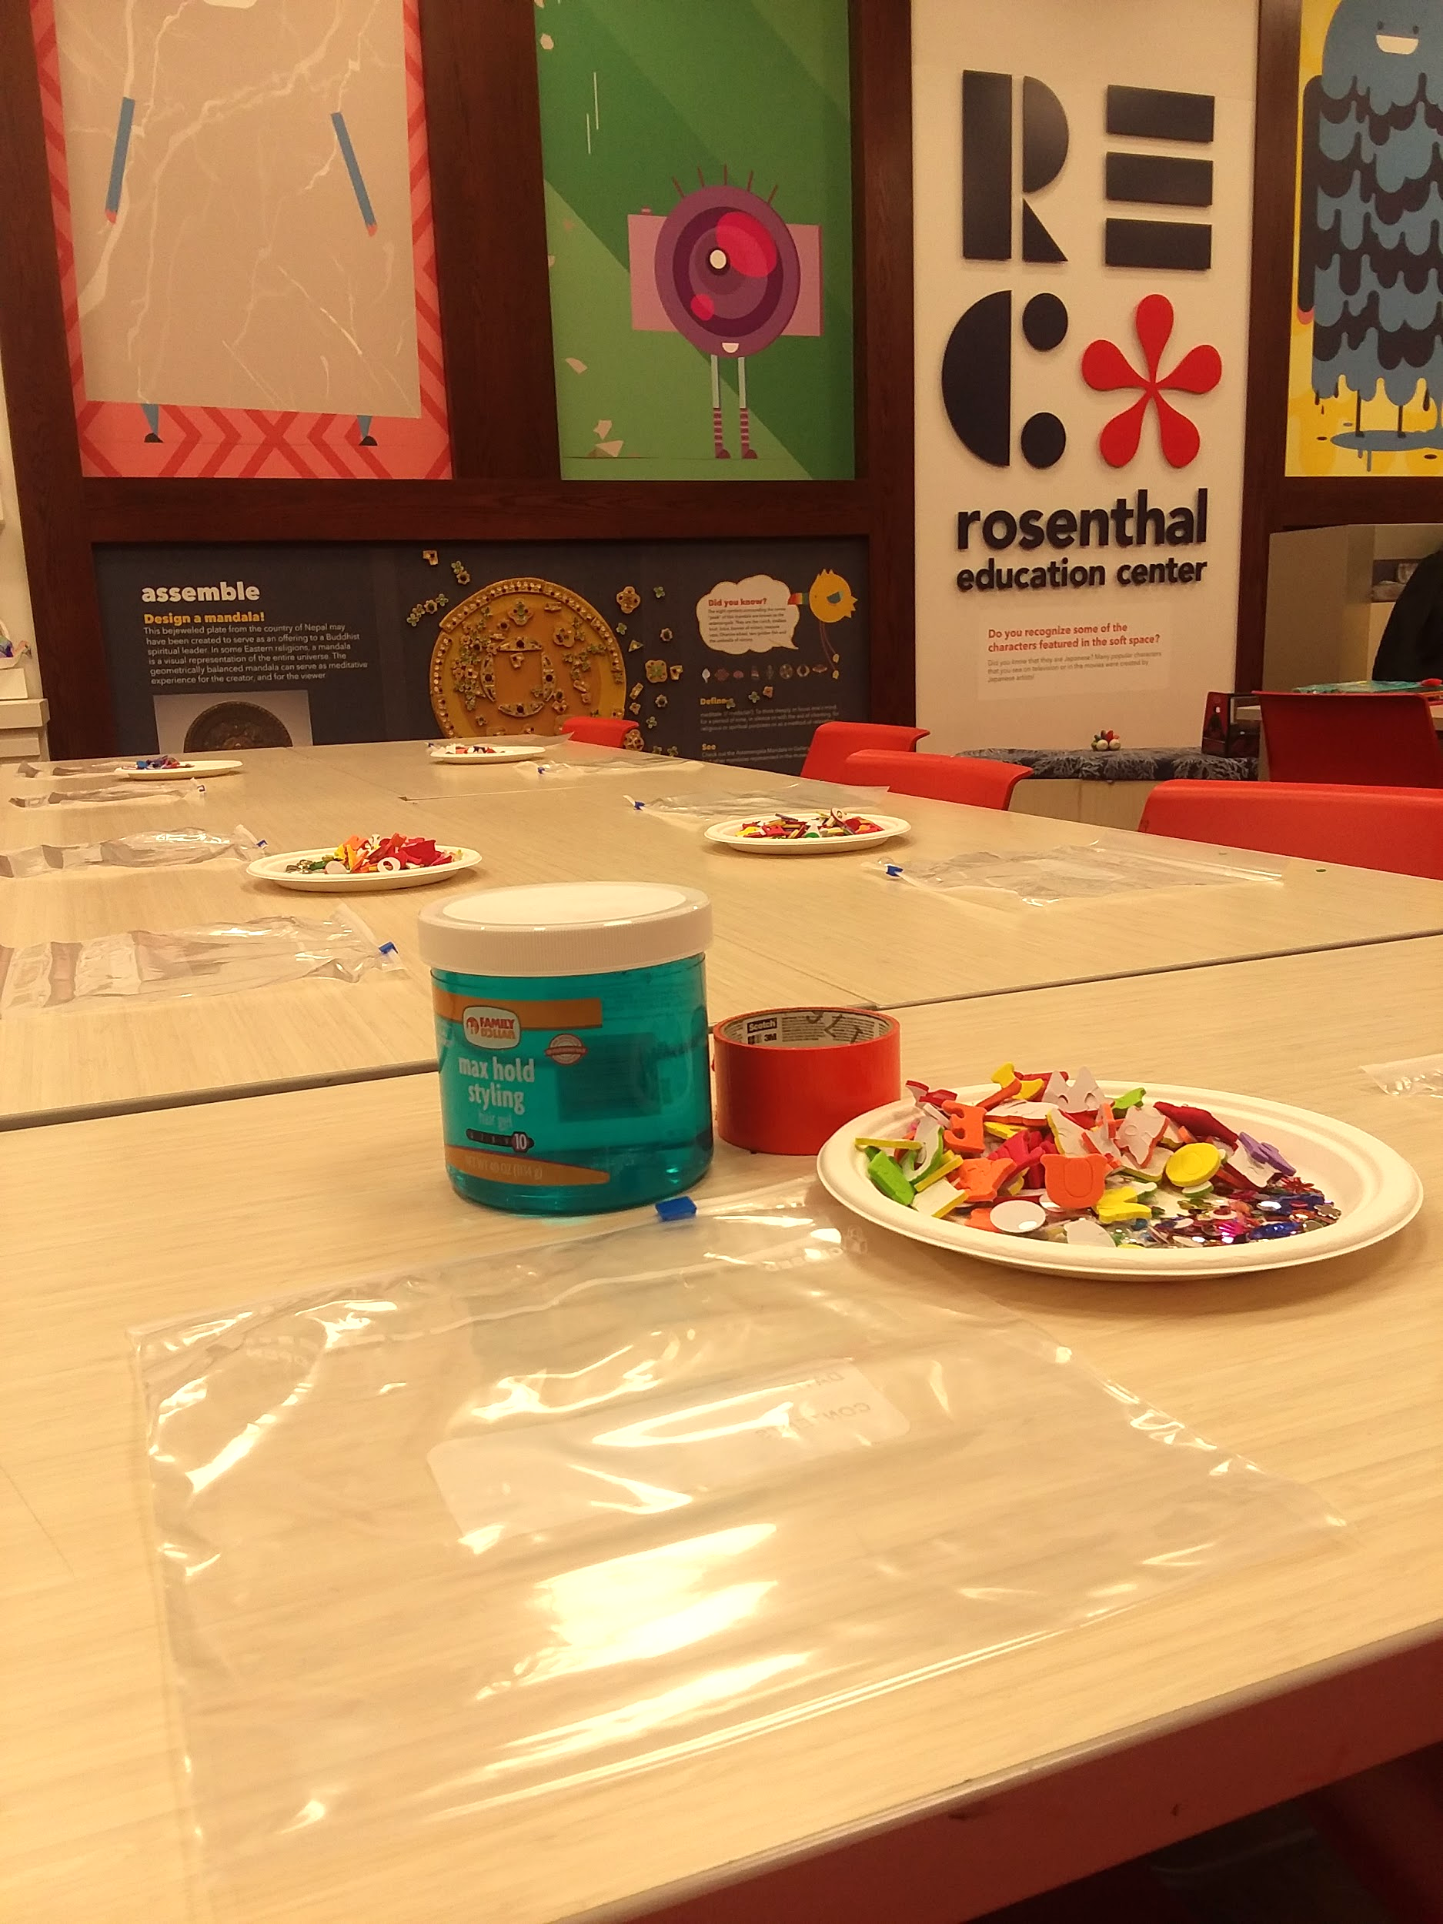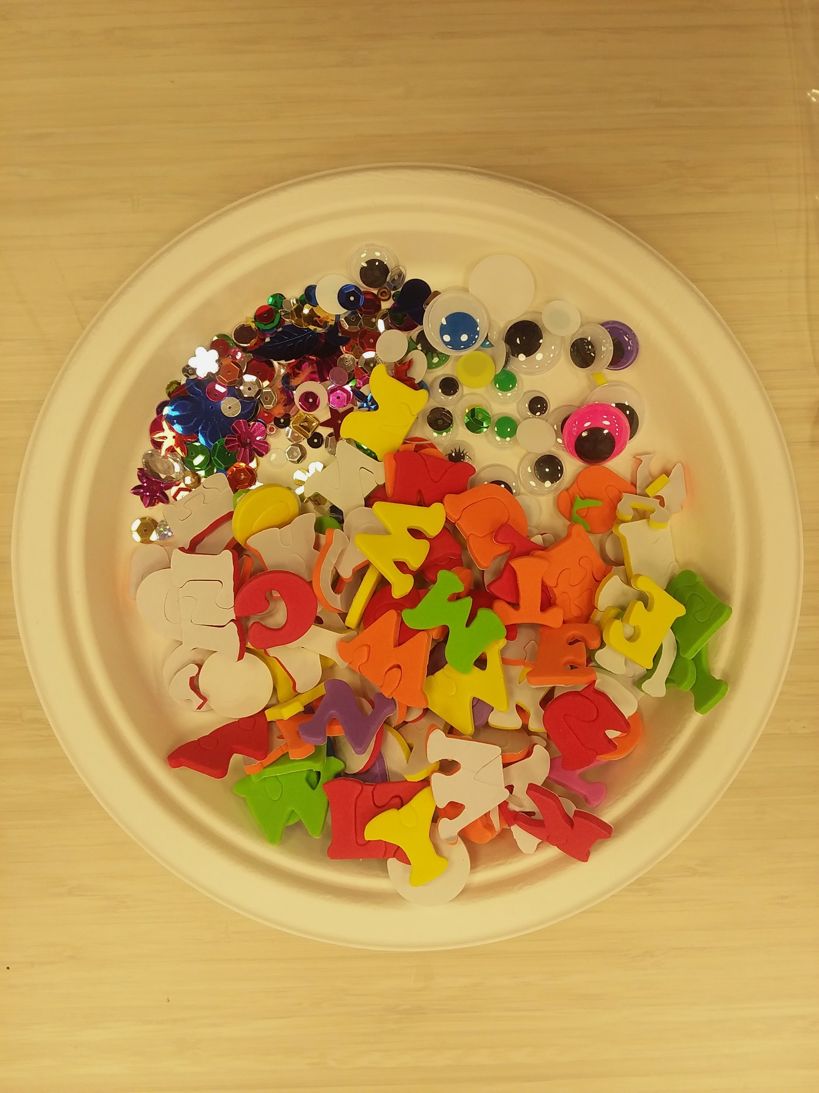

RELATED RESOURCES
Use these books to guide the lesson and add more meaning to the students’ artmaking.
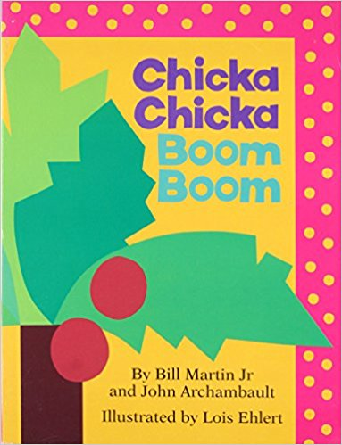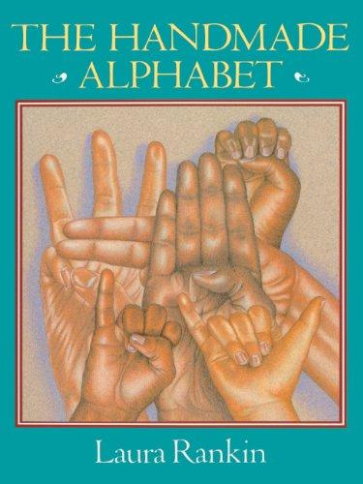
Chicka Chicka Boom Boom The Handmade Alphabet
By Bill Martin Jr. by Laura rankin

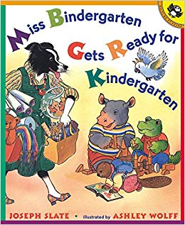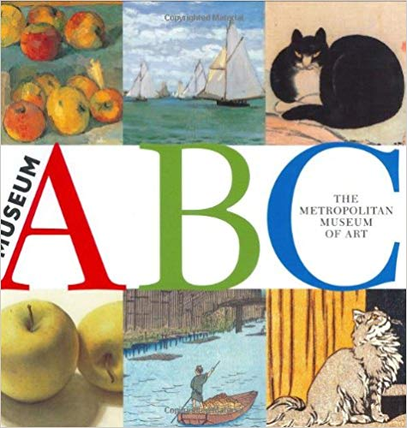
Miss Bindergarten Gets ready Museum A B C
for Kindergarten By The Metropolitan Museum of Art
By Joseph Slate

ADDITIONAL ACTIVITIES
Incorporate these additional learning activities to enhance the lesson.
- Sing the Alphabet Song with your students.
- Teach the American Sign Language Alphabet:

